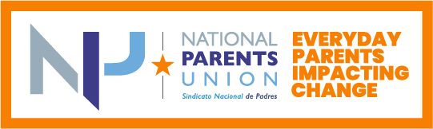

2022 Grant Application

The National Parents Union (NPU) launched the watchdog campaign, Everyday Parents Impacting Change (EPIC), to shine a light on the degree to which elected officials are serving the interests of kids, specifically related to ARP ESSER funds. This is the moment to reimagine education! We don’t want to return to “normal.” Join us in our efforts to seek bold changes in how our kids are educated.

To Apply
To apply, please download, complete and submit this enclosed Grant Application by providing the information as requested below. You can refer back to the full Request for Proposal here.

Grant Applications must be submitted to Vivett Dukes, Deputy Director of Organizing, NPU by emailing vivett@npunion.org no later than 11:59 p.m. ET on June 1, 2022.

Award Notifications
Grant awards will be announced July 8, 2022.

The project period for this grant is August - December 2022.

Successful grantees must be eligible to work in the United States and will be required to provide a completed W9 to NPU upon approval of grant.

Application
Please provide the information outlined in this section.

Contact Information
Name:
Email:
Phone:
Address:

Sample Budget Template
Please complete the following sample budget template, assuming you’re awarded the full $5,000 grant to spend exclusively on EPIC campaign related activities from August - December 2022.

Item | Subtotal | Narrative
Sample: in-person parent information night | Estimated cost $400 for 20 parents includes food and drink | Parents will be trained on messages that work when talking to school board members about ARP/ESSER
Transportation
Child Care assistance
Food/Drink (Estimated at $20/person for events of 20 people; (Set up vendor accounts with Panera, Dominoes, Chipotle, Papa John’s)
Printing (flyers, palm cards)
T-shirts/clothing for parent
$25 Gift Cards for parents (incentivize this part. Have fun with it -- what kind of gift cards would your community most appreciate?)
Holiday celebration/appreciation
Other (please specify)
TOTAL | $ must not exceed $5,000

Please respond to the following prompts.

- Tell us more about you. What was the catalyst for you becoming a parent leader? What is the origin story of your advocacy? Please be as specific as possible. Max 250 words.

- What impact do you plan to have relative to the EPIC campaign in the lives of the community you serve and walk alongside? Please be as specific as possible. Max 250 words.

- Who are the current parents and families you serve? How do you plan to rally them in support of the idea you’ve proposed and/or help them to hold school boards accountable? Max 250 words.

Questions?
If you have any questions about the EPIC Campaign RFP or how to submit your grant application, please reach out to Vivett Dukes, Deputy Director of Organizing, NPU, by emailing vivett@npunion.org.

